**API Automation testing : Project Experience**

**Index**

**1. Introduction**

**2. Framework Details**

**3. Test Cases Design for API Testing 4. Project Details**

**5. Help(Slack Channel)**

**6. Review**

**1. Introduction**

QE Studio strongly believes in learning with evolving technology and different types of testing. This leads to the start of our initiative for essential training for all TAEs. We started with Mandatory training for API Automation with Rest Assured Java to our TAEs who didn't have experience for the same skill. We are starting the 2nd Phase of the same initiative by providing project level experience for the same skill.

**After completion of this phase, respective TAEs can add 4-6 months of API Automation experience in their CV.**

| **Sr. No** | **Phases** | **Description** | **Duration** |
| --- | --- | --- | --- |
| 1 | Phase 1 | Mandatory Training | Jun-Oct 2022 |
| 2 | Phase 2 | Project Experience | 15th Nov 2022- 25th Dec 2022 |

**2. Framework Details**

At the time of Mandatory training, we used sample Framework to

complete the assignments. We will use the same framework to complete our project level experience. Everyone has to understand the framework pattern and details so that they can explain the same framework for their project

experience.

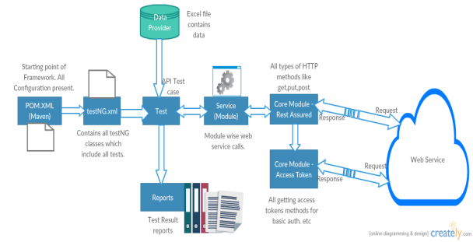**Framework Location :**

**3. Test Cases Design for API Testing**

We have a pattern for writing test cases for API. We need to understand this pattern. One of our Tech Manager **Prankur** has documented a really good document which provides detailed test cases for API testing. Generally we should write below different types of test cases in API.

1. Positive Scenario

2. Negative Scenario

3. User Business Flow Scenario(Cascading of APIs)

4. Role Based Test Scenario

5. Schema Comparison Scenario

Please refer to the document below to design different test scenarios. Reference Doc

**4. Project Details**

Our Globant Team has developed Rest Services : Find Missing Child(FMC). They have developed different required HTTP methods in this service. We need to test this whole service and sign off on the functionality.

Swagger Url :

http://fmc-env.eba-5akrwvvr.us-east-1.elasticbeanstalk.com/webjars/swagg er-ui/index.html#/

Each endpoint is self explanatory and any one can understand the purpose of each endpoint.

Please use the below postman collection and import it into Postman. You can play around endpoints in Postman.

Collection :

Below should be output as Project completion

1. Designing All test cases in Excel

2. Bugs List

3. Globant Github Repo : Automation of all API test cases in above given API Automation Framework. Put this Repo link on document and upload same document on GU course

https://university.globant.com/group/5126

4. Endpoints:

Postman Collection :

https://drive.google.com/file/d/1T8LJKEA02Ju-lJw8f7IREqC5n4MU0p71/view ?usp=share_link

Base URL : http://Fmc-env.eba-5akrwvvr.us-east-1.elasticbeanstalk.com

1. User Sign Up

● /fmc/token

● /fmc/email-signup-automation

● /fmc/verify-otp

2. Login

● /fmc/login

3. Password Reset

● /fmc/reset-password

4. File Upload/Download

● /file/upload

● /file/{{file_key}}

5. Add Report/ Get Report

● /fmc/reports

● /fmc/reports/{{content}}

6. Delete User

● /fmc/delete-user

**5. Help**

We are going to use the same Slack channel which we have used for mandatory training. If you are not part of below channel then please connect with **Mahesh Bhandigare**/**Smita Shewale**. You can ask all questions on these slack channels, our Mentors will help you. Also on Every Friday 4.30 PM to 5.30 PM, we will have a Hangout call, anyone can join and ask the questions/queries.



| **APIAutomationMentors** |
| --- |
| Smita Shewale Sachin Funde Devdatta Chore |
| Lata Sulakhe |

| Girish Bhosale |
| --- |
| Anirudha Patil |

HO Link : meet.google.com/aye-utqd-euv

**6. Review**

CLs have to check their Mentee’s regular progress for this Project work. They need to provide final status for their mentee. We have our Panel also who can help you for any evaluation. Progress Tracker

**References**

**Lombok Set up : https://www.baeldung.com/lombok-ide Json to POJO: https://json2csharp.com/json-to-pojo**